Basavarajeswari group of Institutions

**BALLARI INSTITUTE OF TECHNOLOGY & MANAGEMENT, BALLARI**

** “Jnana Gangotri" Campus, No.873/2, Ballari-Hospet Road, Allipur, **

**Ballari-583 104 (Karnataka State)**

2021-2022

**C PROJECT LAB-2021-22**

**A Mini-Project Report On**

**“TELECOM BILLING SYSTEM”**

**A project work designed and developed as a part of C PROJECT LAB for the Academic Year 2021-22.**

**PROJECT ASSOCIATES:**

**Polepalli Vishnu Sai 3BR12CS126**

**Nikhil Kumar 3BR12CS115**

**Ralf Edward David 3BR12CS131**

**Meghna Patil 3BR12CS122**

**ABSTRACT**

This is C Projects a TELECOM BILLING SYSTEM which provided a lot of facility to their user. The scope of my Project TELECOM BILLING SYSTEM is to record the details various activities of user. It will simplify the task and reduce the paper work. During implementation every user will be given appropriate training to suit their specific needs. Specific support will also be provided at key points with in the academic calendar. Training will be provided on a timely basis, and you will be trained as the new is TELECOM BILLING SYSTEM rolled out to your area of responsibility. At the moment we are in the very early stages, se it is difficult to put a specific time and the training, but we will keep people in termed as plans are developed. The system is very user friendly and it is anticipated that functions of the system will be easily accessed by administrators, academics, students and applicants. Hence the management system for the College management has been designed to remove all the deficiency from which the present system is suffering.

**INTRODUCTION**

The purpose of the project is to present the requirement of the Computerization of TELECOM BILLING SYSTEM. The project thus calculates the telephone bills automatically. It does almost every work which is related to automatic telephone: billing connection system via new connection, customer record modification. viewing customer records & all works related to rate of bill, meter readings in addition to bill calculation and bill generation. TELECOM BILLING SYSTEM is developed as per seeing the increasing requirement to speed up the work and incorporate a new wore culture. Thus, a new software has been proposed to reduce manual work, immersing wars efficiency, saving time and to provide greater flexibility and user-friendliness as the system previously followed was totally manuals, She with lots of errors*.*

**OBJECTIVES**

The functions and features used in this project are listed below:

* Add new records: add new data into file with name, phone number and amount to be paid
* View list of records – lists all telephone billing records (as shown in screenshot 3)
* Modify records – edit the added records; name, phone number and/or amount of payment can be edited
* View payment – shows amount to be paid
* Search records – search for added/updated records in file
* Delete records – removes data permanently from file

**DRAWBACKS OF EXISTING SYSTEM**

In the existing system all the office works was done manually. The manual work processes were time consuming and hence slow. Following are the main draw backs of the existing system:

The existing system is totally manual thus there are chances of error in processing.

The basic and major drawbacks in the existing system are the speed of retrieval of data from files, which leads to delay.

Maintenance of voluminous data is very cum boresome and laborious job.

The manual jobs such as calculation are more error prone.

There are plenty of chances of duplicity of data and information.

**ADVANTAGES - Of the proposed system.**

* Simple application with easy to understand and print bill details.
* We can add more features by adding more modules to software.
* Manual paper work process will be reduced and data is secured.
* The companies effectively utilize the telecom billing system for tracking expenses, usage and assets etc. These can support in effective preparation and analysis of business reports. These reports act as tool for taking the right business decisions which work positively for the industry.

**PROBLEM STATEMENT...**

With this **c project in Telecom billing system**, you can perform and manage billing operations like they do in Telecom companies. Here, you can add records with name, phone number and the amount of payment. You can view, modify, search and delete existing records.

You can also make payment by providing your phone number instead of name. All data added or modified are recorded in a file. This project will teach you how to add, list, edit, search and delete records using file handling.

**SCOPE FOR FURTHER IMPROVEMENT**

Every project whether large or small has some Imitations no matter however diligently developed. In some cases, limitations are small while in other cases they may be broad also. The new system has got some limitations. Major areas where modifications can be done are as follows:

* Our system is not online so further it can be improved.
* The security is limited so some additional arrangement could be made to provide more security to the system.
* There is no provision of complain handling so further it can be added.

**MODULES USED IN THE PROJECT**

Input ()

Main ()

add records ()

listrecords ()

modifyrecords ()

deleterecords ()

searchrecords ()

payment ()

login ()

Output ()

Source code of the c-project.

#include<stdio.h>

#include<conio.h>

#include<windows.h>

#include<stdlib.h>

struct subscriber

{

char phonenumber[20];

char name[50];

float amount;

}s;

void gotoxy(int,int);

void addrecords();

void listrecords();

void modifyrecords();

void deleterecords();

void searchrecords();

void payment();

void login();

char get;

int main()

{ int password;

int phonenumber;

char choice;

system("cls");

system("color 0");

gotoxy(10,2);

system("cls");

system("color 0F");

gotoxy(0,2);

printf("\t\t****************************************************************");

printf("\n\t\t ------WELCOME TO THE TELECOM BILLING MANAGEMENT SYSTEM OF VISHNU------"); printf("\n\t\t****************************************************************");

printf("\n\n\n\t\t Press Any Key To Continue. . ");

Sleep(0);

getch();

system("cls");

login();

system ("color 0F");

system("cls");

system ("color 0F");

gotoxy(30,0);

system("color 0F");

printf("\n\n\xDB\xDB\xDB\xDB\xDB TELECOM BILLING SYSTEM \xDB\xDB\xDB\xDB\xDB");

while (1){

printf(" \n\n \xDB\xDB 1 : Add New Records.\n\n \xDB\xDB 2 : List Of Records");

printf("\n\n \xDB\xDB 3 : Modify Records.\n\n \xDB\xDB 4 : For Payment");

printf("\n\n \xDB\xDB 5 : Search Records.");

printf("\n\n \xDB\xDB 6 : Delete Records.\n\n \xDB\xDB 7 : Exit\n");

printf("\n Enter Your Choice:-");

choice=getch();

choice=toupper(choice);

switch(choice)

{

case '1':

addrecords();

break;

case '2':

listrecords();

break;

case '3':

modifyrecords();

break;

case '4':

payment();

break;

case '5':

searchrecords();

break;

case '6':

deleterecords();

break;

case '7':

printf("\nThank you\n");

exit(0);

break;

default:

system("cls");

system("color 0F");

gotoxy(30,20);

printf("Incorrect Input");

printf("\a......");

gotoxy(30,24);

printf("Any key to continue");

getch();

}

}

}

COORD coord = {0, 0};

// sets coordinates to 0,0

//COORD max_buffer_size = GetLargestConsoleWindowSize(hOut);

COORD max_res,cursor_size;

void gotoxy (int x,int y)

{

coord.X = x; coord.Y = y;

// X and Y coordinates

SetConsoleCursorPosition(GetStdHandle(STD_OUTPUT_HANDLE), coord);

}

void addrecords()

{

FILE *f;

char test;

f=fopen("pro.txt","ab+");

if(f==0)

{ f=fopen("pro.txt","wb+");

system("cls");

printf("Please wait while we configure your computer");

printf("\npress any key to continue");

getch();

}

while(1)

{

system("cls");

printf("\n Enter phone number: ");

scanf("%s",&s.phonenumber);

printf("\n Enter name: ");

fflush(stdin);

scanf("%s",&s.name);

printf("\n Enter amount: ");

scanf("%f",&s.amount);

fwrite(&s,sizeof(s),1,f);

fflush(stdin);

printf("\n\n Record Is Successfully Added");

printf("\n Press esc Key to exit or Press any other key to add other record:");

test=getche();

if(test==27)

break;

}

fclose(f);

system("cls");

}

void listrecords()

{

FILE *f;

int i;

if((f=fopen("pro.txt","rb"))==NULL)

exit(0);

system("cls");

printf("Phone Number\t\tUser Name\tAmount\n");

for(i=0;i<79;i++)

printf("-");

while(fread(&s,sizeof(s),1,f)==1)

{

printf("\n%s\t\t%s\t\tRs. %.2f /-",s.phonenumber,s.name,s.amount);

}

printf("\n");

for(i=0;i<79;i++)

printf("-");

fclose(f);

printf("\n\nPress Any Key To Go Back");

getch();

system("cls");

}

void deleterecords()

{

FILE *f,*t;

char phonenumber[20];

system("cls");

f=fopen("pro.txt","rb+");

t=fopen("pro1.txt","wb+");

do{

rewind(f);

printf("Enter the phone number to be deleted from the Database: ");

scanf("%s",phonenumber);

while(fread(&s,sizeof(s),1,f)==1)

{

if(strcmp(s.phonenumber,phonenumber)!=0)

{ fwrite(&s,sizeof(s),1,t);

}

else

printf("Record deleted successfully.");

}

fclose(f);

fclose(t);

remove("pro.txt");

rename("pro1.txt","pro.txt");

f=fopen("pro.txt","rb+");

t=fopen("pro1.txt","wb+");

printf("\nDo you want to delete another record (y/n):");

fflush(stdin);

}

while(getche()=='y'||getche()=='Y');

fclose(f);

getch();

system("cls");

}

void searchrecords()

{

FILE *f;

char phonenumber[20];

int flag=1;

f=fopen("pro.txt","rb+");

fflush(stdin);

system("cls");

printf("Enter Phone Number to search in our database: ");

scanf("%s", phonenumber);

while(fread(&s,sizeof(s),1,f)==1)

{

if(strcmp(s.phonenumber,phonenumber)==0)

{ system("cls");

printf(" Record Found ");

printf("\n\nPhonenumber: %s\nName: %s\nAmount: Rs.%0.2f\n",s.phonenumber,s.name,s.amount);

flag=0;

break;

}

else if(flag==1)

{ system("cls");

printf("Requested Phone Number Not found in our database");

}

}

getch();

fclose(f);

system("cls");

}

void modifyrecords()

{

FILE *f;

char phonenumber[20];

long int size=sizeof(s);

if((f=fopen("pro.txt","rb+"))==NULL)

exit(0);

system("cls");

printf("Enter phone number of the subscriber to modify: ");

scanf("%s",phonenumber);

fflush(stdin);

while(fread(&s,sizeof(s),1,f)==1)

{

if(strcmp(s.phonenumber,phonenumber)==0)

{

system("cls");

printf("\n Enter phone number: ");

scanf("%s",&s.phonenumber);

printf("\n Enter name: ");

fflush(stdin);

scanf("%[^\n]",&s.name);

printf("\n Enter amount: ");

scanf("%f",&s.amount);

fseek(f,-size,SEEK_CUR);

fwrite(&s,sizeof(s),1,f);

break;

}

}

fclose(f);

system("cls");

}

void payment()

{

FILE *f;

char phonenumber[20];

long int size=sizeof(s);

float amt;

int i;

if((f=fopen("pro.txt","rb+"))==NULL)

exit(0);

system("cls");

printf("Enter phone number of the subscriber for payment: ");

scanf("%s",phonenumber);

fflush(stdin);

while(fread(&s,sizeof(s),1,f)==1)

{

if(strcmp(s.phonenumber,phonenumber)==0)

{

printf("\n ***DETAILS***");

printf("\n Phone No.: %s",s.phonenumber);

printf("\n Name: %s",s.name);

printf("\n Current amount: %f",s.amount);

printf("\n");

for(i=0;i<79;i++)

printf("-");

printf("\n\nEnter amount of payment: ");

fflush(stdin);

scanf(" %f",&amt);

s.amount=s.amount-amt;

fseek(f,-size,SEEK_CUR);

fwrite(&s,sizeof(s),1,f);

break;

}

}

printf("\n\n");

printf("System Message: THANK YOU %s FOR YOUR TIMELY PAYMENTS!!",s.name);

getch();

fclose(f);

system("cls");

}

void login()

{

int a=0,i=0;

char uname[10],c=' ';

char pword[10],code[10];

char user[10]="user";

char pass[10]="pass";

do

{

printf("\n ************************** LOGIN FORM ************************** ");

printf(" \n ENTER USERNAME:-");

scanf("%s", &uname);

printf(" \n ENTER PASSWORD:-");

while(i<4)

{

pword[i]=getch();

c=pword[i];

if(c==4) break;

else printf("$");

i++;

}

pword[i]='\0';

//char code=password;

i=0;

//scanf("%s",&password);

if(strcmp(uname,"user")==0 && strcmp(pword,"pass")==0)

{

printf(" \n\n\n WELCOME TO OUR SYSTEM !!!! LOGIN IS SUCCESSFUL");

printf("\n\n\n\t\t\t\tPress any key to continue...");

getch();//holds the screen

break;

}

else

{

printf("\n SORRY !!!! LOGIN IS UNSUCESSFUL");

a++;

getch();//holds the screen

system("cls");

}

}

while(a<=2);

if (a>2)

{

printf("\nSorry you have entered the wrong username and password for four times!!!");

getch();

}

system("cls");

}

**Results:**

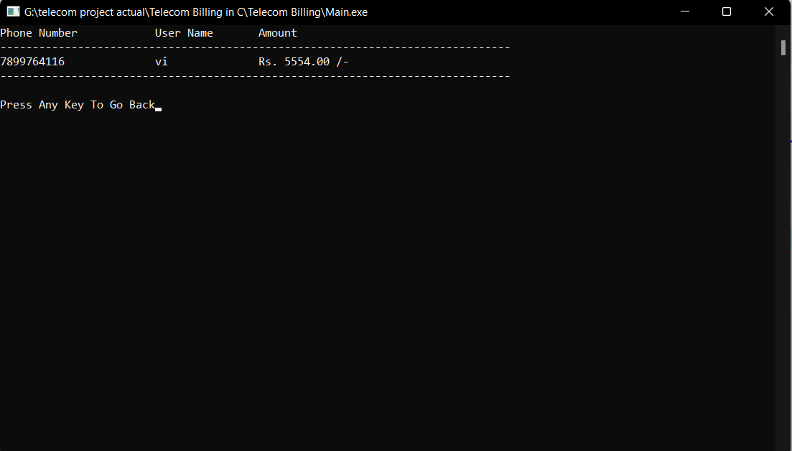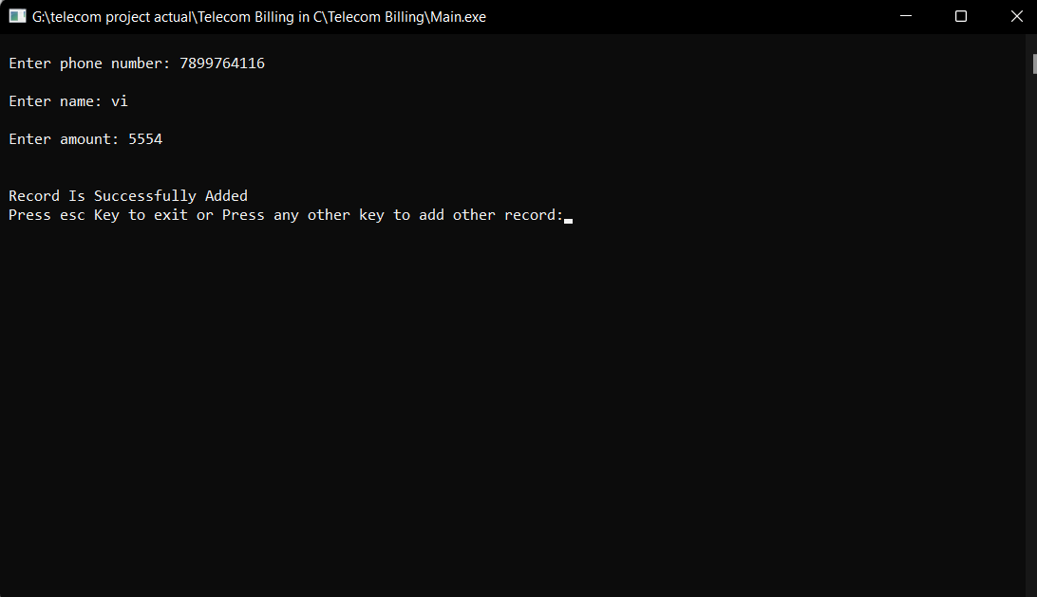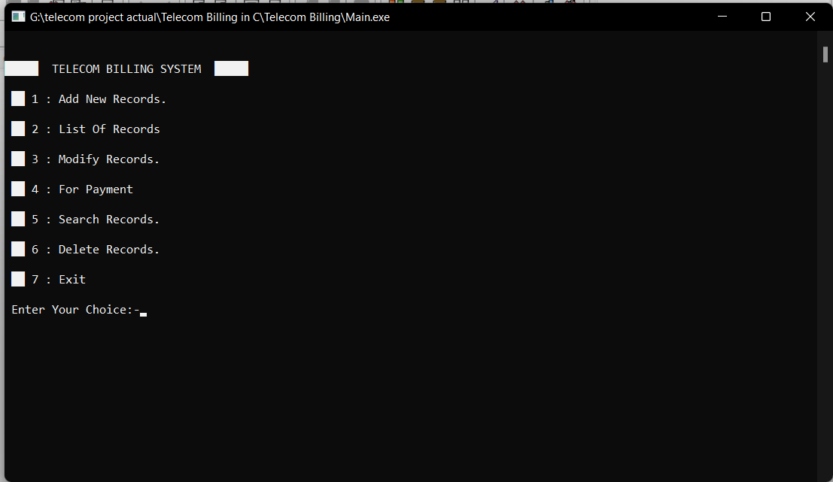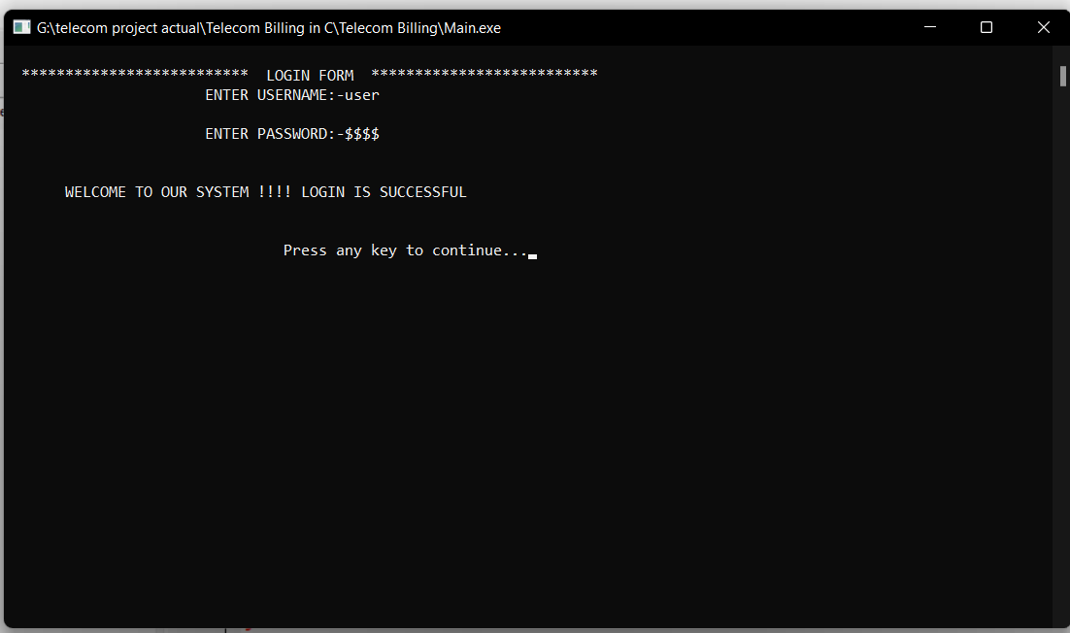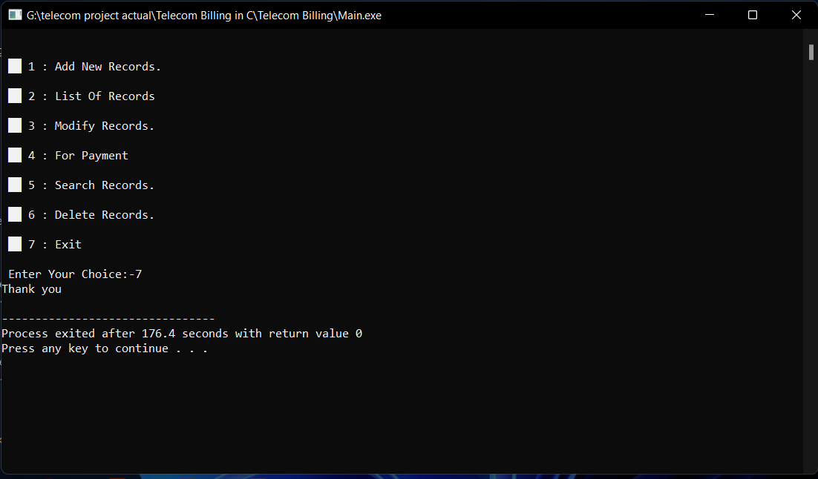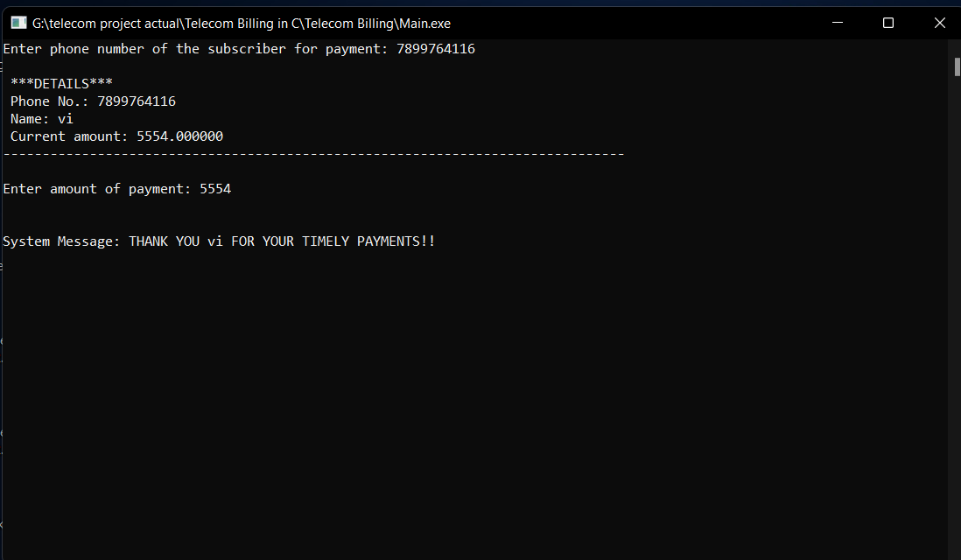

**Conclusion**

All these features and benefits of telecom billing solution reinforce its importance in the telecommunication industry. Technologies like convergent billing cloud technology are expected to change the scenario of billing system and make it more effective.

**REFERENCE**

1.Text book: C programming by DENNIS RITCHIE.

2.Data structures with c by A.M Padma Reddy, Sri Nandi Publications ,Bangalore..

***************************************************